Practical programs OS

Name: Ramagiri Rishik
Sec: 6

1)VIRTUAL ADDRESS
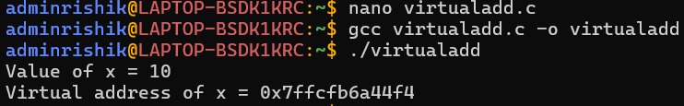

2)DEMAND PAGING
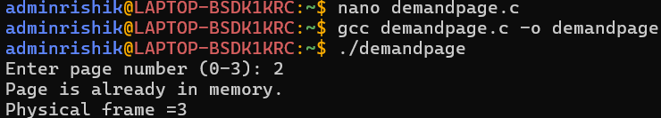

3)ADDRESS SPACE
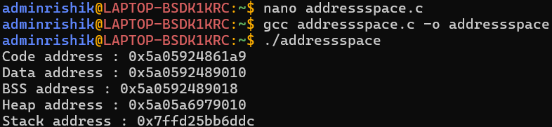

4)ADDRESS TRANSILATION
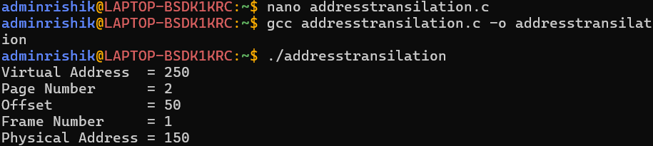

5)DYNAMIC MEMORY
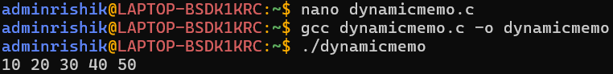

6)NULL POINTER
